Name: Sharat N

Roll_No: 7179KCTKCTKCTKCTKCTKCTKCT19BCS086

|  |
| --- |
| Branch: Computer Science Engineering |
|  |

LITERATURE REVIEW

Existing solutions:

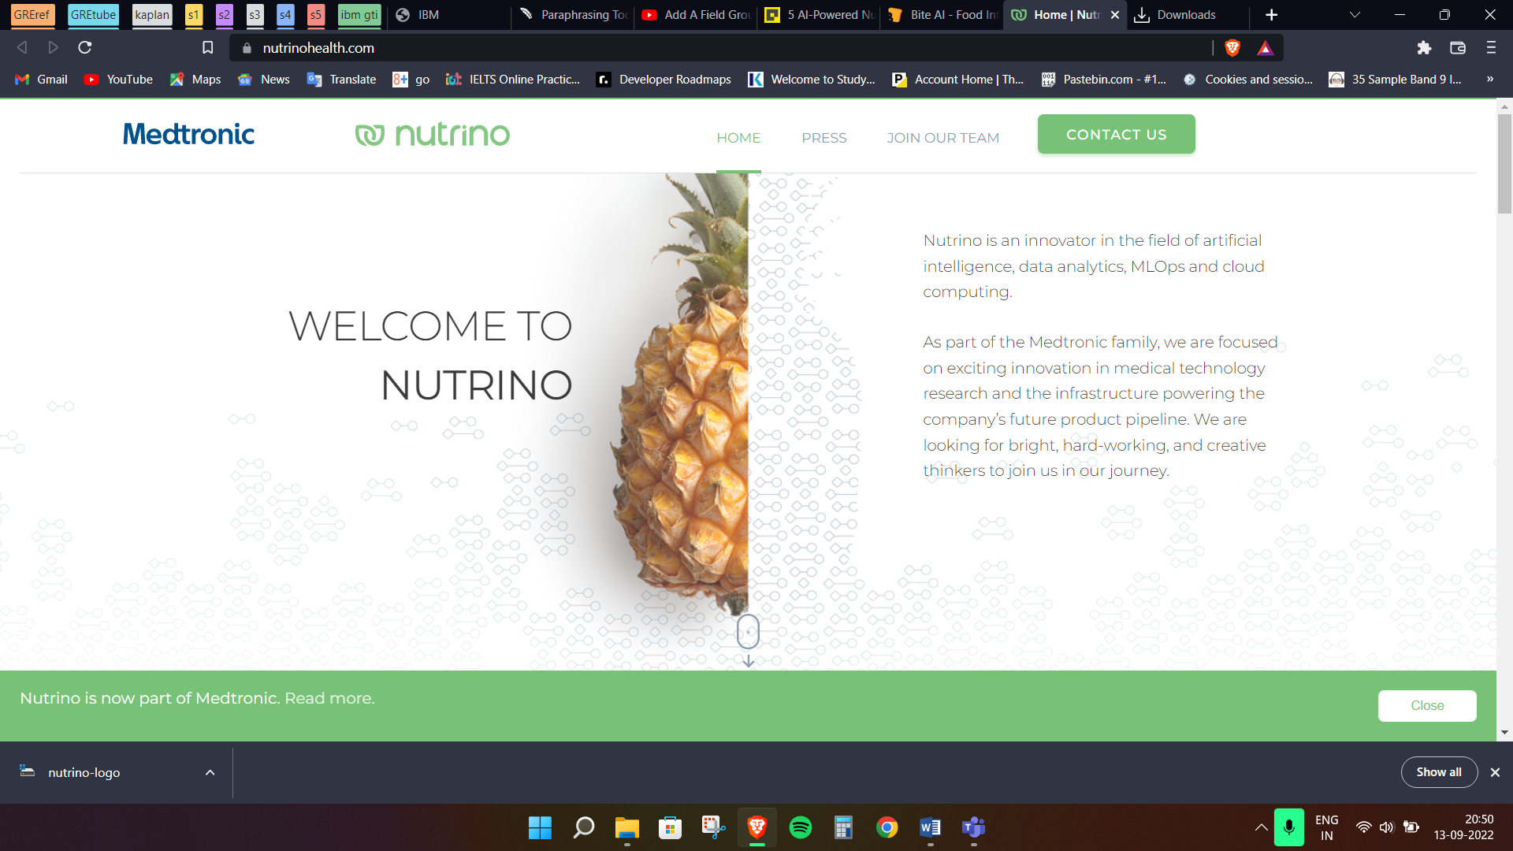

Neutrino: The platform offers its customers nutrition-based data services, analytics, and technology and aspires to become a top source of knowledge into nutrition. The platform makes use of NLP, mathematical models from optimization theory, and predictive analysis to enable individualised data compilation.

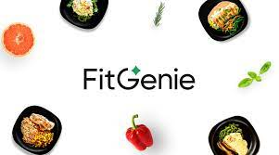

FitGenie: The software largely depends on AI to generate customised calorie consumption data and create food recommendations in line with that data. Their sophisticated diet analysis and calorie counter tools work together to produce dynamic and adaptable macronutrient modifications, producing high-quality nutrient plans for their users every week that are derived from their 1+ million food options.



Calorie Mama: The app combines artificial intelligence (AI) and image classification technologies to precisely and accurately identify the meal and to compute the number of calories merely from the image. The most culturally diversified food identification system in the world, their proprietary Food AI API has been taught to recognise foods from around the globe. Furthermore, the food that the platform recognises automatically is combined with comprehensive nutrition information thanks to the API's connections to other data sets.



Bite AI: is yet another online platform that analyses what users consume to identify trends in terms of popular dishes consumed by users and consumption times. It does this using deep learning and image recognition. The machine learning enables features like the identification of previous meals, the making of hierarchical predictions—that is, the detection of high-level categories like soup and beverages as well as particular dishes and ingredients. Additionally, it interacts with their Food Knowledge Graph, which includes a sizable collection of frequently consumed items, nutrition information, and a hierarchical structure. The software further deconstructs nutritional data, including calories, macro- and micronutrients, and ingredients.



Suggestic: The app's machine-learning algorithm collects information about users from their food and health tracking devices in order to tailor food recommendations and offer responses throughout the day via a chatbot. By just pointing your app at the menu list, it features a great function that employs augmented reality to suggest menu items in a restaurant. Currently, the app is accessible through the iStore.

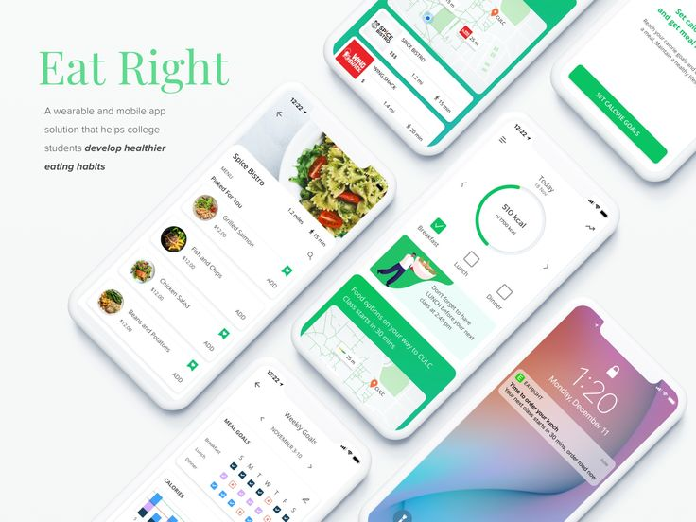

Eat Right: Amos Wong's Eat Right app is a platform for individualised dietary recommendations. The programme recognises the items on a menu using artificial intelligence and machine learning algorithms, and then gives the user the nutritional value that a dish would deliver.

GitHub projects on this topic:

[virajmane](https://github.com/virajmane)/[FoodCalorieEstimation](https://github.com/virajmane/FoodCalorieEstimation)

Link: https://github.com/virajmane/FoodCalorieEstimation

About: Estimates live food calories and nutrition information from image

[MaharshSuryawala](https://github.com/MaharshSuryawala)/[Food-Image-Recognition](https://github.com/MaharshSuryawala/Food-Image-Recognition)Public

Link: https://github.com/MaharshSuryawala/Food-Image-Recognition

About: A system that takes food images as an input, recognizes the food automatically and gives the nutritional-facts as an output.